COAL – Lab 6 – Lab tasks

Task 1:
INCLUDE Irvine32.inc

.data
promptInput BYTE "Enter an integer: ", 0
resultMsg BYTE "Smallest even number is: ", 0
noEvenMsg BYTE "No even numbers entered.", 0
smallestEven SDWORD ?
foundEven BYTE 0

.code
main PROC
mov ecx, 10
input_loop:
mov edx, OFFSET promptInput
call WriteString
call ReadInt
push eax
loop input_loop

mov ecx, 10
mov foundEven, 0
find_even_loop:
pop eax
test eax, 1
jnz not_even
cmp foundEven, 0
jne compare_smallest
mov smallestEven, eax
mov foundEven, 1
jmp next_value
compare_smallest:
mov ebx, smallestEven
cmp eax, ebx
jge next_value
mov smallestEven, eax
next_value:
not_even:
loop find_even_loop

cmp foundEven, 0
je no_even_found
mov edx, OFFSET resultMsg
call WriteString
mov eax, smallestEven
call WriteInt
call Crlf
jmp done
no_even_found:
mov edx, OFFSET noEvenMsg
call WriteString
call Crlf
done:
exit
main ENDP
END main

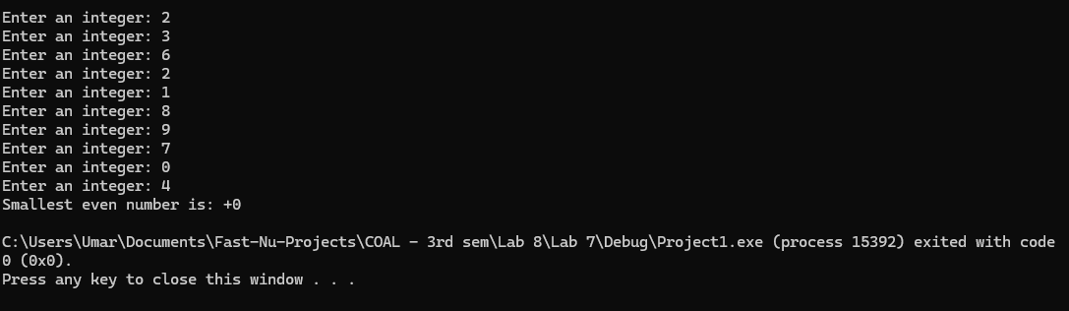

Task 2:
INCLUDE Irvine32.inc

.data
promptInput BYTE "Enter salary: ", 0
salaryMsg BYTE "Salaries entered:", 0
sumMsg BYTE "Sum of salaries: ", 0
avgMsg BYTE "Average salary: ", 0
salaries SDWORD 5 DUP(?)
sum SDWORD ?
average SDWORD ?

.code
main PROC
call InputSalaries
exit
main ENDP

InputSalaries PROC
mov ecx, LENGTHOF salaries
mov esi, OFFSET salaries
input_loop:
mov edx, OFFSET promptInput
call WriteString
call ReadInt
mov [esi], eax
add esi, TYPE salaries
loop input_loop
call ComputeResults
ret
InputSalaries ENDP

ComputeResults PROC
mov ecx, LENGTHOF salaries
mov esi, OFFSET salaries
mov eax, 0
sum_loop:
add eax, [esi]
add esi, TYPE salaries
loop sum_loop
mov sum, eax
mov ebx, LENGTHOF salaries
cdq
idiv ebx
mov average, eax
call DisplayResults
ret
ComputeResults ENDP

DisplayResults PROC
mov edx, OFFSET salaryMsg
call WriteString
call Crlf
mov ecx, LENGTHOF salaries
mov esi, OFFSET salaries
display_loop:
mov eax, [esi]
call WriteInt
call Crlf
add esi, TYPE salaries
loop display_loop
mov edx, OFFSET sumMsg
call WriteString
mov eax, sum
call WriteInt
call Crlf
mov edx, OFFSET avgMsg
call WriteString
mov eax, average
call WriteInt
call Crlf
ret
DisplayResults ENDP

END main

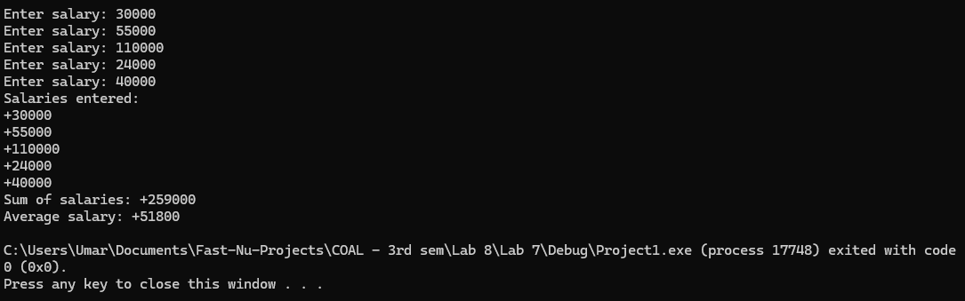

Task 3:
INCLUDE Irvine32.inc

.data
promptK BYTE "Enter temperature in Kelvin: ", 0
msgK BYTE "Kelvin: ", 0
msgC BYTE "Celsius: ", 0
msgF BYTE "Fahrenheit: ", 0
msgFlags1 BYTE "Flags before pop: ", 0
msgFlags2 BYTE "Flags after pop: ", 0
kelvin SDWORD ?
celsius SDWORD ?
fahrenheit SDWORD ?
flagsStored DWORD ?

.code
main PROC
mov edx, OFFSET promptK
call WriteString
call ReadInt
mov kelvin, eax

mov eax, kelvin
sub eax, 273
mov celsius, eax

pushfd
pop eax
push eax
mov flagsStored, eax

mov eax, celsius
imul eax, 9
cdq
mov ebx, 5
idiv ebx
add eax, 32
mov fahrenheit, eax

mov edx, OFFSET msgK
call WriteString
mov eax, kelvin
call WriteInt
call Crlf

mov edx, OFFSET msgC
call WriteString
mov eax, celsius
call WriteInt
call Crlf

mov edx, OFFSET msgF
call WriteString
mov eax, fahrenheit
call WriteInt
call Crlf

mov edx, OFFSET msgFlags1
call WriteString
mov eax, flagsStored
call WriteHex
call Crlf

pop eax
mov edx, OFFSET msgFlags2
call WriteString
call WriteHex
call Crlf

exit
main ENDP
END main

